**EXPERIMENT NO- 05**

**AIM:** Configuration of Cisco Router 2900

**OBJECTIVE:**  To demonstrate Configuration of Cisco Router 2900

**ALGORITHM:**

1. Start
2. Setup the Topology and initialize devices
3. Configure Devices and router and verify connectivity
4. Display Device information
5. End

**DESCRIPTION AND EXECUTION:**

Resources: 2 Switch, 2 PCs, 2 Router.

|  |  |  |  |  |
| --- | --- | --- | --- | --- |
| Device | Interface | IP Address | Subnet Mask | Def. Gateway |
| R1 | Fa0/0 | 192.168.1.1 | 255.255.255.0 | N/A |
| S0/0/0 | 192.168.2.1 | 255.255.255.0 | N/A |
| R2 | Fa0/0 | 192.168.3.1 | 255.255.255.0 | N/A |
| S0/0/0 | 192.168.2.2 | 255.255.255.0 | N/A |
| PC1 | N/A | 192.168.1.10 | 255.255.255.0 | 192.168.1.1 |
| PC2 | N/A | 192.168.3.10 | 255.255.255.0 | 192.168.3.1 |

**Connecting the devices using cables:**

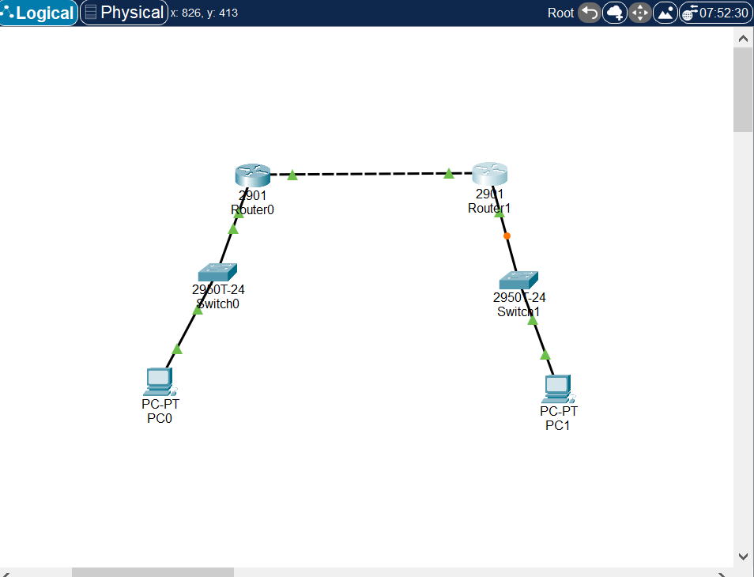

**Configuring PC-A and PC-B:**

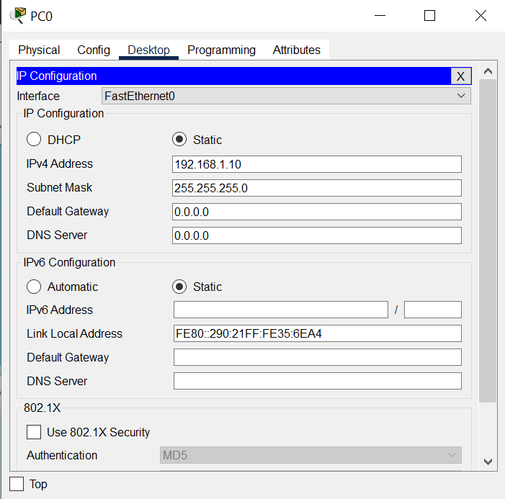

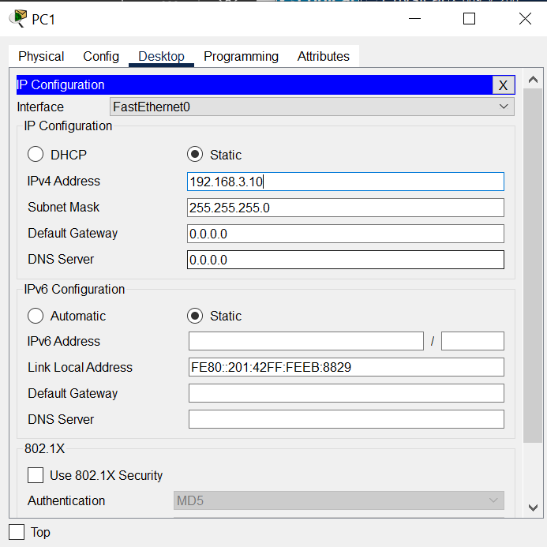

**Configuring router 1:**

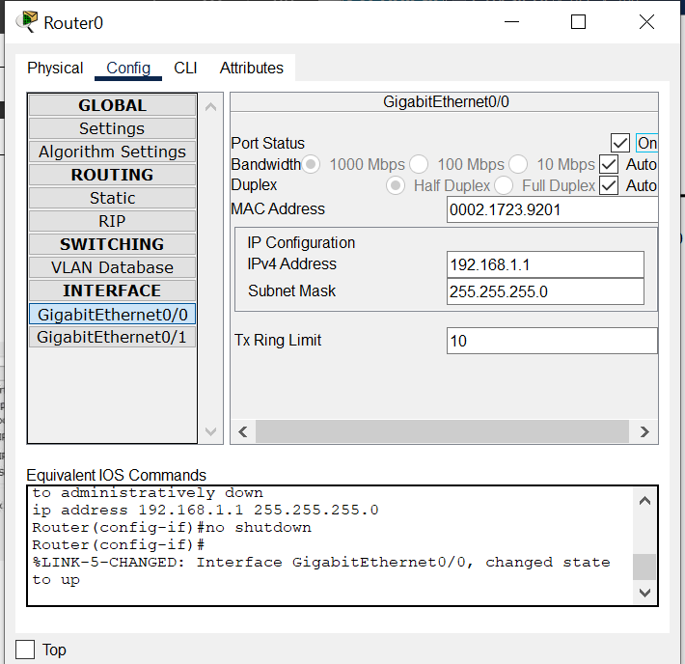

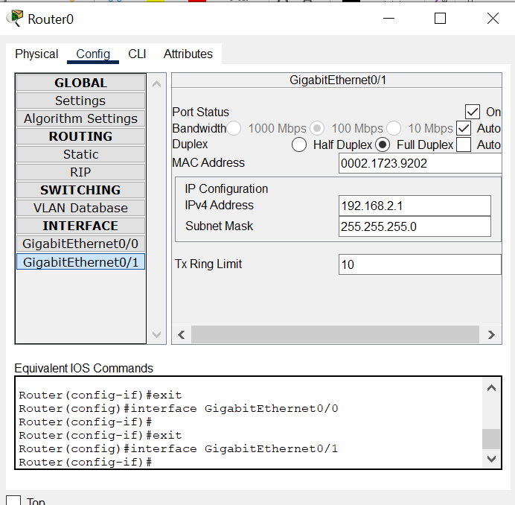

**Configuring router 2:**

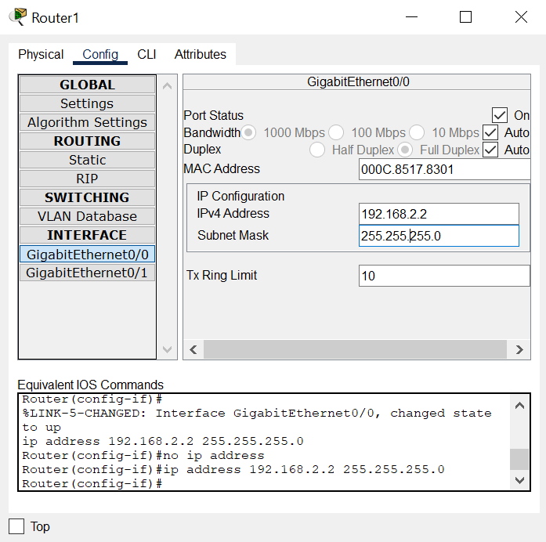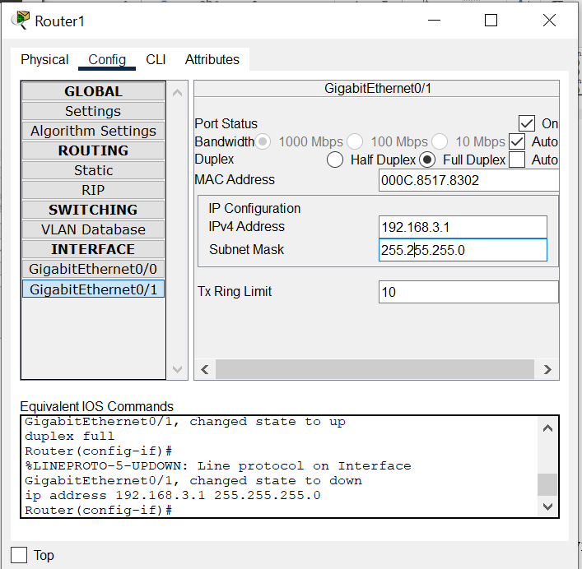

**Checking ping from PCA to PCB:**

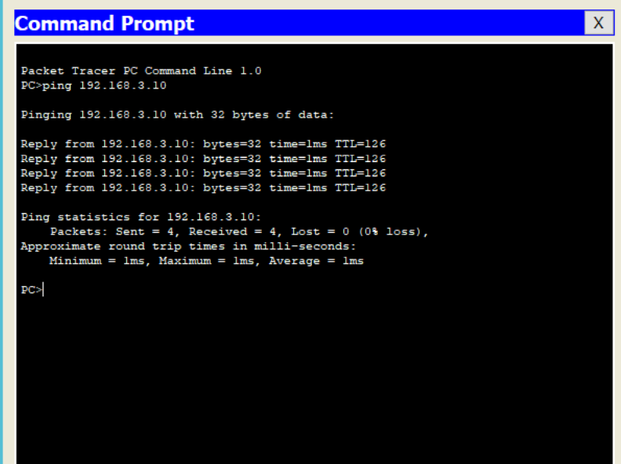

**RESULTS:**  After the configuration and connection of all devices, the ping is successful from PC-A to PC-B